**Experiment No: 16**

**Name of the Experiment:** Study Of Trapezoidal Integral Method To Calculate Integral Value Of A Function With Limit.

**Objectives:** The objective of this experiment is to use Trapezoidal Integral Method to calculate integral value of any limited function, using MATLAB.

**Theory:** a The Trapezoidal Rule for approximating b∫af(x)dx is given by

b∫af(x)dx≈Tn=Δx2[f(x0)+2f(x1)+2f(x2)+⋯+2f(xn−1)+f(xn)],

where Δx=b−an and xi=a+iΔx.

As n→∞, the right-hand side of the expression approaches the definite integral b∫af(x)dx [1].

**Tool:** MATLAB Software

**Methodology:**

**MATLAB Code:**

%Function declaration

f= @(x) 2*x+3 ;

a=0;b=6;

n=b-a;

%height

h = (b - a) / n;

%Trapizoidal formula

sum_x = 0;

for i = 1:(n - 1)

x = a + i * h;

sum_x = sum_x + f(x);

end

xi = h / 2 * (f(a) + 2 * sum_x + f(b));

%Output

xi

**Output:**

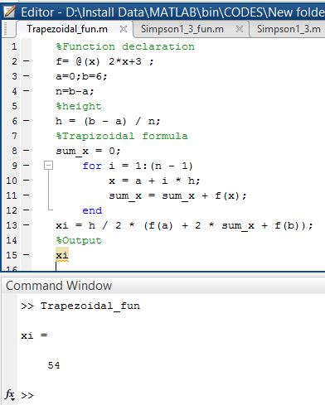

**Result(s)& Discussion:** The is 54.

**Conclusion:** We have found the exact integral value of function 2x+3 from limit 0 to 6 which is same as the calculated value (∫**60 2x+3 dx**).

**References:**

[1]C. Chapra and P. Canale Raymond , “*Numerical Methods for Engineers”,* 7th ed. McGraw-Hill Education, 2 Penn Plaza, New York, NY 10121, 2015